Name : Cheruvathoor Abin Anto

Roll No : TIT2425008

**Implementation of Naive Bayes Classification in Python**

**Step 1: Import libraries & Step 2: Import data**

# Import libraries

import pandas as pd

import numpy as np

import matplotlib.pyplot as plt

import seaborn as sns

from sklearn.preprocessing import LabelEncoder

from sklearn.preprocessing import StandardScaler

from sklearn.model_selection import train_test_split

from sklearn.naive_bayes import GaussianNB

from sklearn.metrics import accuracy_score

from sklearn.metrics import confusion_matrix

# Read dataset

df_net = pd.read_csv('D:/Aby/IDS/P6/Social_Network_Ads.csv')

df_net.head()

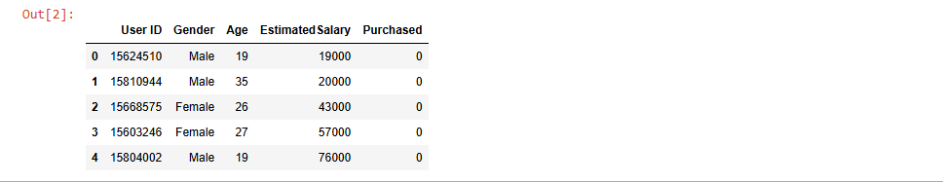

# Step 3: Data Analysis / Preprocessing

# Get required data

df_net.drop(columns = ['User ID'], inplace=True)

df_net.head()

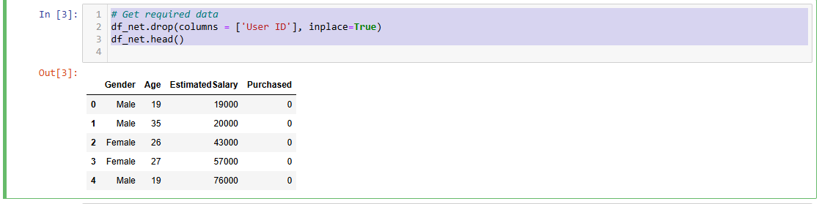

**Describe data**

df_net.describe()

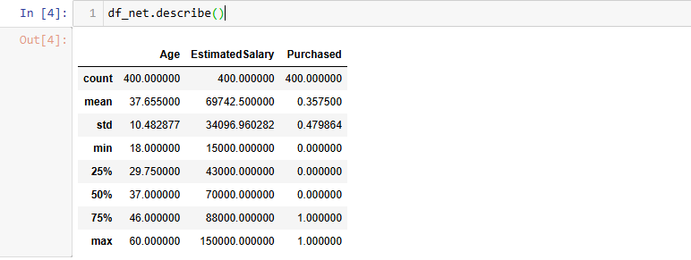

**Distribution of Data**

sns.distplot(df_net['EstimatedSalary'])

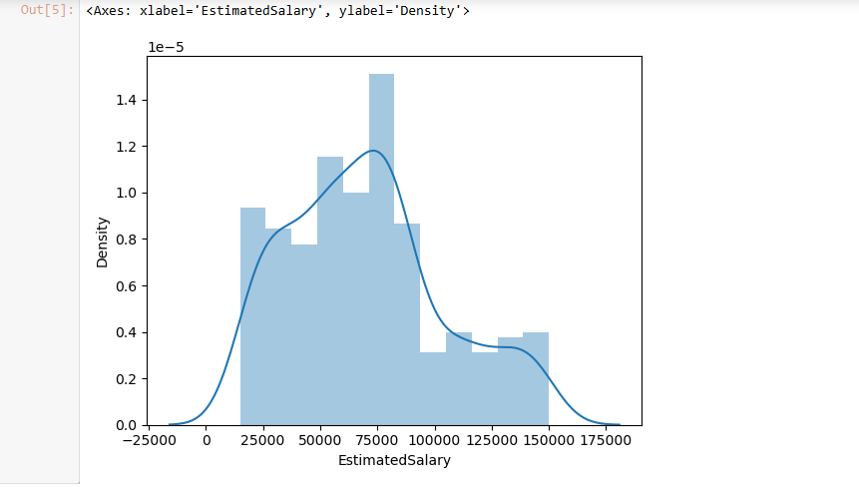

**Label encoding**

le = LabelEncoder()

df_net['Gender']= le.fit_transform(df_net['Gender'])

df_net

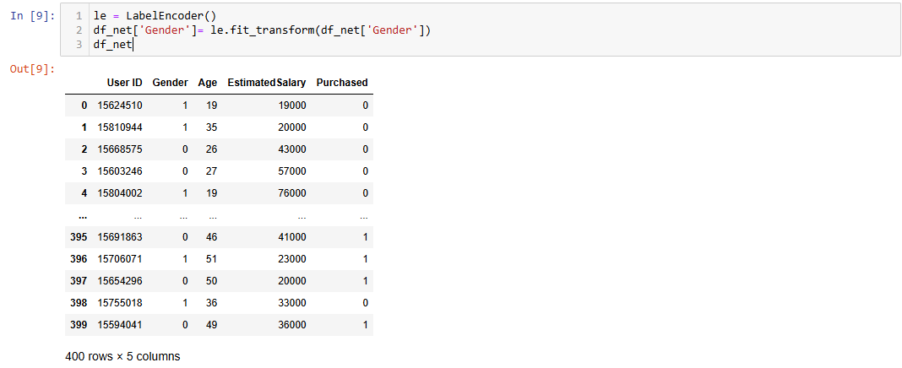

df_net['Gender']

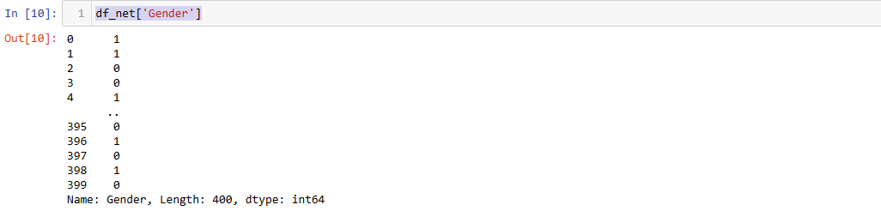

df_net.corr()

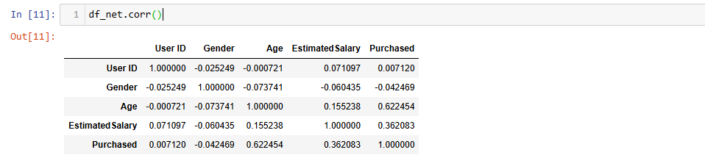

sns.heatmap(df_net.corr())

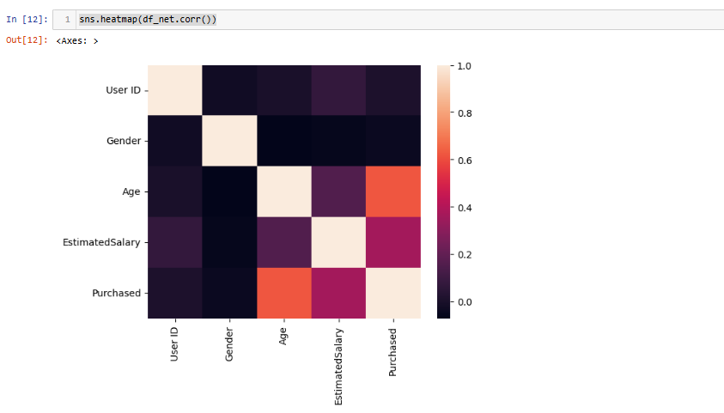

df_net.drop(columns=['Gender'], inplace=True)

df_net

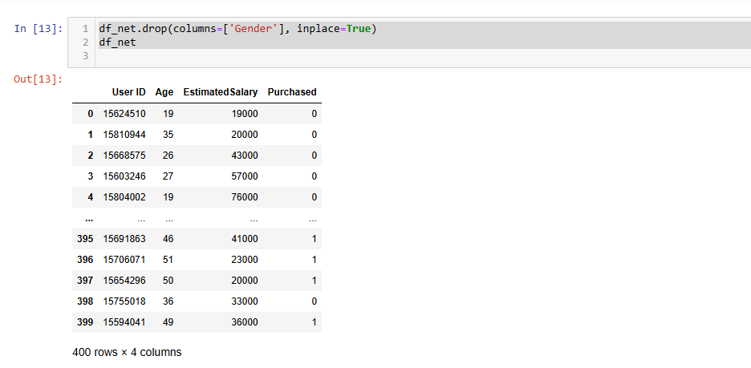

# Step 4: Split data

# X = df_net.iloc[:, :-1].values

# # all rows and all columns except the last one(-1)

# X

# 

# y = df_net.iloc[:, -1].values

# # Selects the last column

# y

# 

# This is important because if the model is trained and tested on the same data, it may over-fit the data and perform poorly on new, unseen data.

# We have split the data into 75% for training and 25% for testing.

# X_train, X_test, y_train, y_test = train_test_split(X, y, test_size = 0.25, random_state = True)

# Step 5: Feature scaling

# sc = StandardScaler()

# X_train = sc.fit_transform(X_train)

# X_test = sc.transform(X_test)

# X_train

# 

# 

# classifier = GaussianNB()

# classifier.fit(X_train, y_train)

# 

# Step 7: Predict result / Score model

# y_pred = classifier.predict(X_test)

# print(np.concatenate((y_pred.reshape(len(y_pred), 1), y_test.reshape(len(y_test), 1)), 1))

# Step 8: Evaluate model

# accuracy_score(y_test, y_pred)

# 

**Confusion matrix**

cf_matrix = confusion_matrix(y_test, y_pred)

sns.heatmap(cf_matrix, annot=True, fmt='d', cmap='Blues', cbar=True)

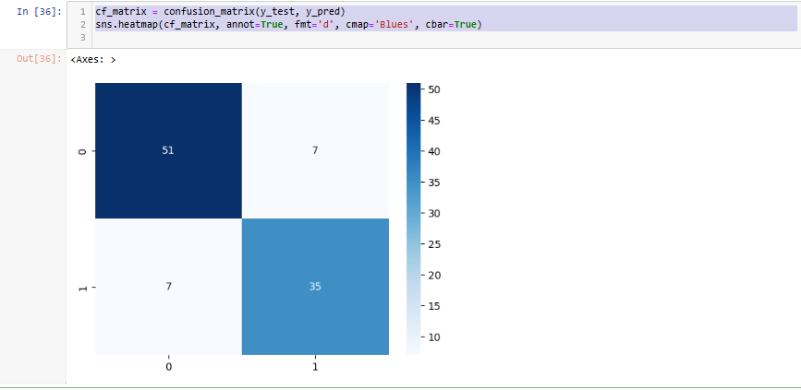

print(classifier.predict(sc.transform([[45, 97000, 0]])))



***Ch. 5 ) Logical Regression***

**1 )   
 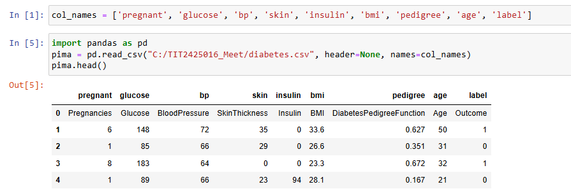**

**2 )**

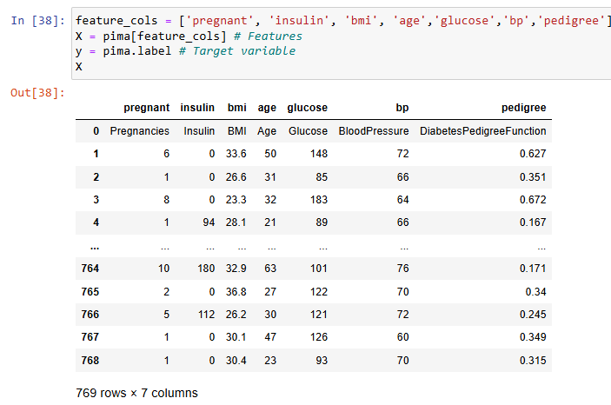

**3)**

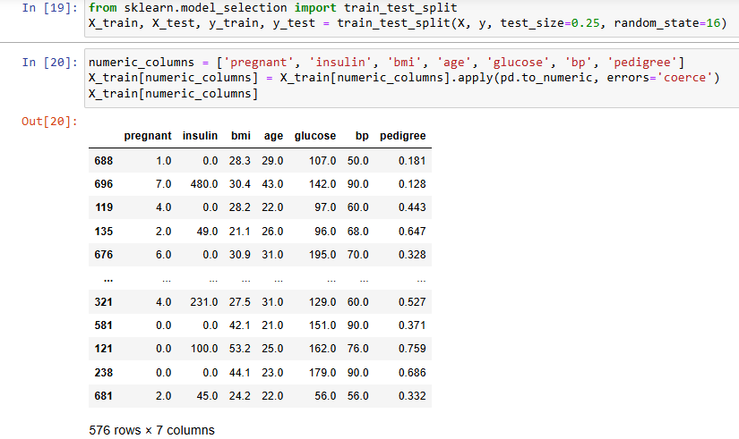

**4)**

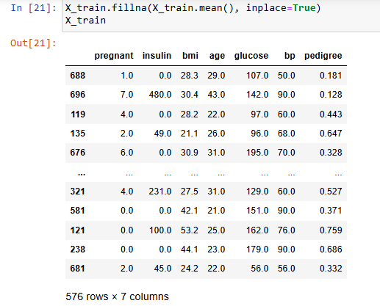

**5)**

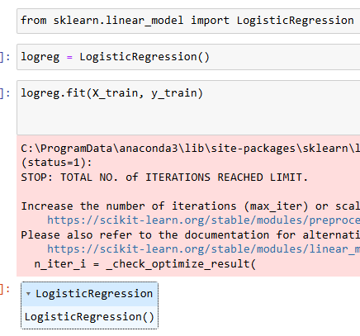

**6)**

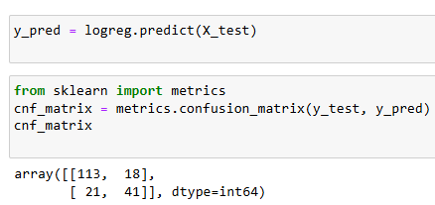

**7)**

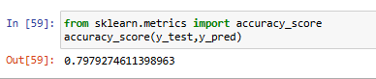

**8)**

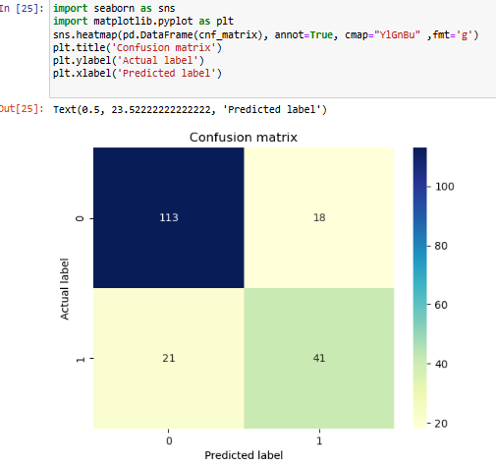

**Ch. 5 )** **Support Vector Machine using python**

**1)**

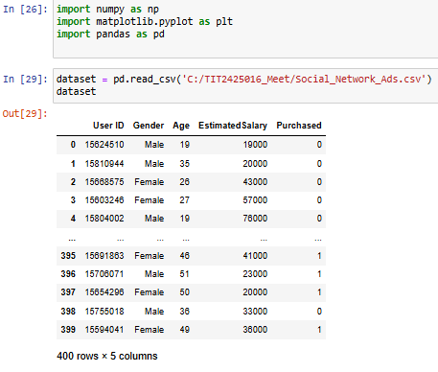

**2)**

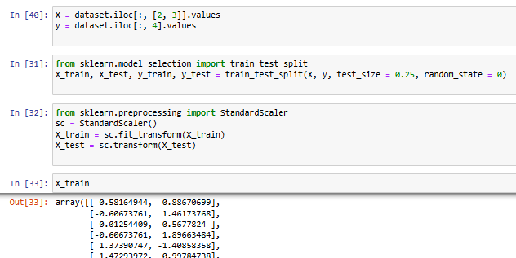

**3)**

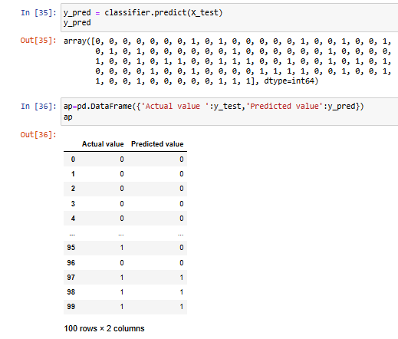

**4)**

